# INTRODUCTION

* 1. Overview

Retail management is the process of running and managing retail outlets' day-to-day activities surrounding the selling of goods and services to customers.

* 1. Purpose

A retail management system (RMS) is a platform that combines several modules to aid in the day-to-day operation of a retail store or chain, such as managing and buying inventory, checking out customers, scheduling employee shifts, keeping track of finances, etc.

1. **Problem Definition & Design Thinking**
   1. Empathy Map

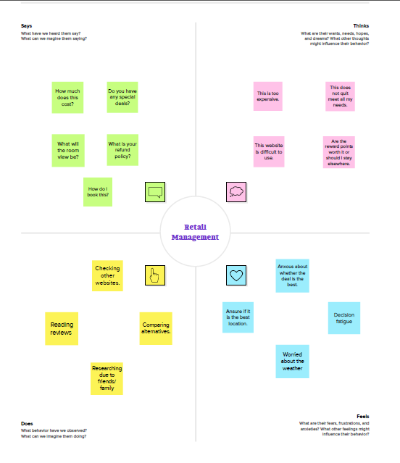

* 1. Ideation & Brainstorming Map

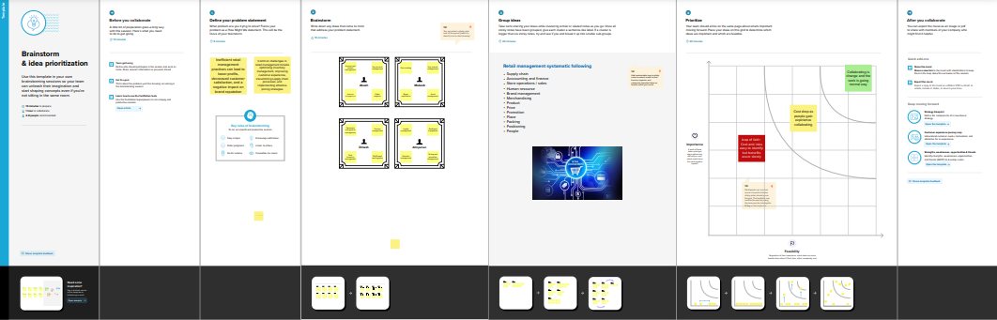

# RESULT

* 1. Data Model:

|  |  |
| --- | --- |
| Field label | Data type |
| Campaign | text |
| Leads | date |

|  |  |
| --- | --- |
| **App** | **Object** |
| Sales app |  |
| Service app |  |

# Activity & Screenshot

|  |  |
| --- | --- |
| Field label | Data type |
| Cases |  |
| Acccounts |  |

# 

# 

# Trailhead Profile Public URL

**Team Leader ;** **https://trailblazer.me/id/aakash365**

**Team Member 1 -https://trailblazer.me/id/athi02**

# Team Member 2 https://trailblazer.me/id/dinesh035

# TMember 3

https://trailblazer.me/id/mukesh456

1. **ADVANTAGES**

* **Less capital requirement**
* **More profit margin**
* **Credit facility**
* **Better customer relation**
* **No liability**

**DISADVANTAGES;**

* **High marketing cost**
* **Selling skill required**
* **Very high competition**
* **No economies of buying**
* **It requires proper location**

# APPLICATIONS

* Set up
* Sales
* Service
* Trailhead
* github

# CONCLUSION

# Whether you have a small shop for a big store if you are running a retail business, then retail management is must to run it efficiently.Either you are seller or a cudtomer, everybody has 24 hours in a day and the time is very important for all.

# FUTURE SCOPE

# The retail sector in the country is currently booming, providing plenty of career prospects fgor people with a passion for sales marketingplaces, business,diversification, campaigning, ADVERTISING, MARKETTING, RESEARCH and segmentation.